Title:
A MaJiang Game among LaoTou, BingXiang, HandsomeZHE, DyingFeng

Time Limit: 6s

Description:
As we all know, MaJiang is a treasure of our Chinese. And in different places, there are different rules to judge whether a set of MaJiang has winning states or not. Later, MaJiang came to Japan, and Japanese made a brand new rule to judge.

To taste the new feeling of playing MaJiang with the different rules, they four decided to try Japanese MaJiang instead of Chinese one. So they found the states of winning on the Internet.

Japanese MaJiang needs four people to sit around a desk and play with a set of Majiang tiles just like Chinese. A set of MaJiang tiles contains four copies of the tiles described next:


One to nine Wan, which we use 1w to 9w to represent;
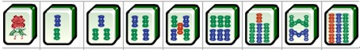

One to nine Tiao, which we use 1t to 9t to represent;
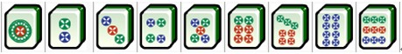

One to nine Bing, which we use 1b to 9b to represent;
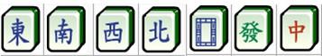

Character tiles, which are: Dong, Nan, Xi, Bei, Bai, Fa, Zhong, which we use 1c to 7c to represent.

A winning state means a set of 14 tiles that normally contains a pair of same tiles (which we call "eyes") and four melds. A meld is formed by either three same tiles(1w, 1w, 1w or 2c, 2c, 2c for example) or three continuous non-character tiles(1w, 2w, 3w or 5t, 6t, 7t for example).

However, there are two special winning states that are different with the description above, which are:
"Chii Toitsu", which means 7 different pairs of tiles;
"Kokushi Muso", which means a set of tiles that contains all these tiles: 1w, 9w, 1b, 9b, 1t, 9t and all 7 character tiles. And the rest tile should also be one of the 13 tiles above.

And the game starts with four players receiving 13 tiles. In each round every player must draw one tile from the deck one by one. If he reaches a winning state with these 14 tiles, he can say "Tsu Mo" and win the game. Otherwise he should discard one of his 14 tiles. And if the tile he throws out can form a winning state with the 13 tiles of any other player, the player can say "Ron" and win the game.

Now the question is, given the 13 tiles you have, does there exist any tiles that can form a winning state with your tiles?

Input:
The input data begins with a integer T(1 <= T <= 25000). Next are T cases, each of which contains 13 tiles. The description of every tile is as above.

Output:
For each cases, if there actually exists some tiles that can form a winning state with the 13 tiles given, print the number first and then print all those tiles in order as the description order of tiles above. Otherwise print a line "Nooten"(without quotation marks).

Sample Input:
2
1b 2b 3b 2c 2c 2c 2t 3t 5w 6w 7w 1t 1t
1b 1b 2b 3b 4t 5t 6t 7c 7c 3t 3t 2w 2w

Sample Output:
2 1t 4t
Nooten

Author:
CireVong

